For The Sake Of The Song
The Story of Anderson Fair

Some fairy tales come true. Some don’t.

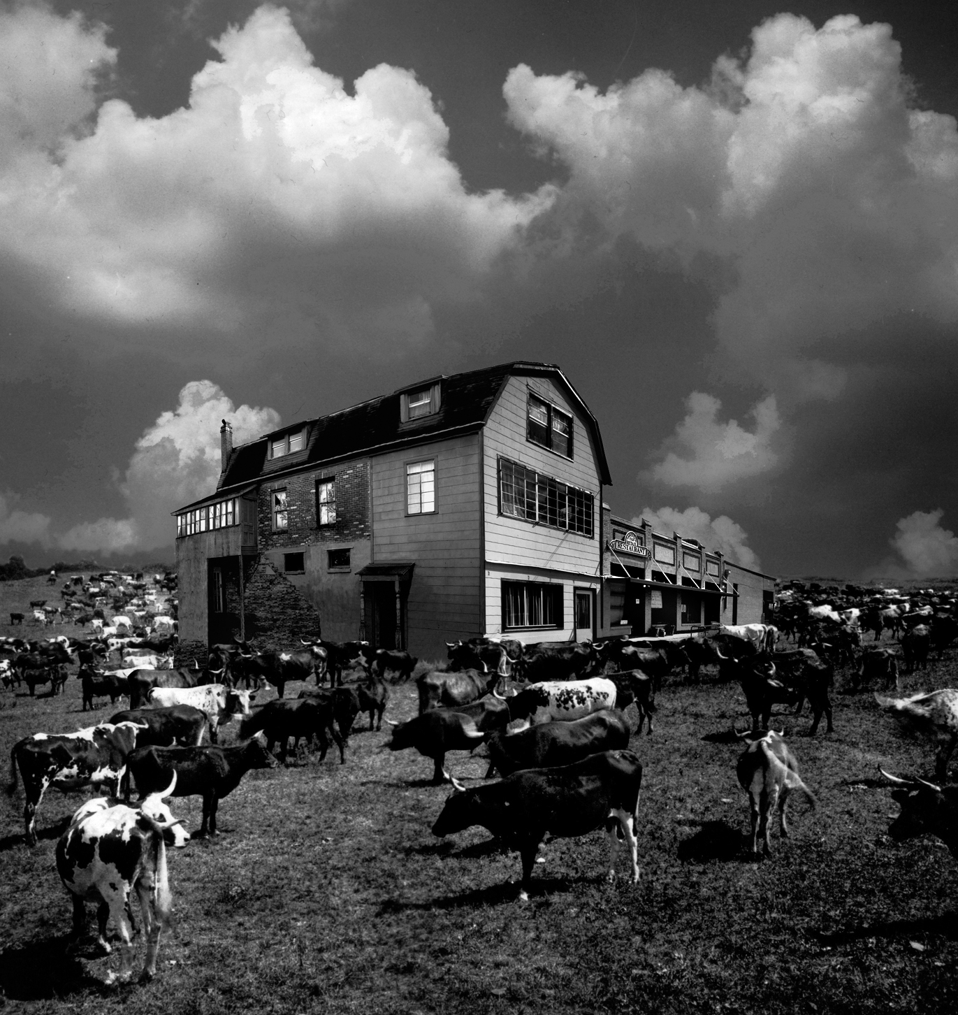

DRAFT

A Ghost Ranch Films production

www.andersonfairthemovie.com

Running time: 86:00 minutes

Contact info:
Jim Barham
Fair Retail Films, LLC
2309 Dryden Rd.
Houston, TX 77030
713-385-3470
jbarinc@sbcglobal.net



For The Sake Of The Song: The Story of Anderson Fair

Log Line
A devoted community of artists, volunteers, and patrons transforms a politically subversive little neighborhood coffee house and restaurant into a unique American music institution.

Synopsis (short)
For The Sake Of The Song: The Story of Anderson Fair is the story of one of Texas’ and America’s unsung cultural treasures and the significant role it has played in preserving an American musical tradition. For forty years, Houston’s legendary folk and acoustic music venue, Anderson Fair Retail Restaurant, has fostered and nurtured some of the most important musical performers and songwriters in America, including Grammy Award-winning artists Nanci Griffith, Lyle Lovett, and Lucinda Williams. This film tells the compelling saga of how a devoted family of volunteers, patrons, and artists transformed a politically subversive little coffee house and restaurant into a unique music institution.

Synopsis (medium)
For forty years, Houston’s legendary folk and acoustic music venue, Anderson Fair Retail Restaurant, has fostered and nurtured some of the most important performers and songwriters in America, including Grammy Award-winning artists Nanci Griffith, Lyle Lovett, and Lucinda Williams. Lyle Lovett claims, “Without Anderson Fair, I wouldn’t have been driven to try to write songs the way I was.” Recalling her early development as a songwriter, Nanci Griffith says, “I wasn’t yet that confident with my songwriting, and Anderson Fair gave me that confidence.”

For The Sake Of The Song: The Story of Anderson Fair is the compelling saga of one of Texas’ and America’s unsung cultural treasures. This film explores the significant role Anderson Fair has played in preserving an American musical tradition and how a devoted family of artists, volunteers, and patrons transformed a politically subversive little coffee house and restaurant into a unique American music institution.

Anderson Fair has stubbornly bucked the odds and survived to become one of the oldest folk and acoustic music venues in continuous operation in the United States. Its endurance can be attributed to the dedication of a community of people with a common vision: nothing gets in the way of the music. Anderson Fair has always been and is still run by volunteers; no one is paid. And its struggle to survive in many ways mirrors the struggle of the individual artists. For The Sake Of The Song tells the tale of this small place in Texas where the sound is true, the spotlight gentle, the applause encouraging, and big things happen.

For The Sake Of The Song: The Story of Anderson Fair

Synopsis

For forty years, Houston’s legendary folk and acoustic music venue, Anderson Fair Retail Restaurant, has fostered and nurtured some of the most important performers and songwriters in America, including Grammy Award-winning artists Nanci Griffith, Lyle Lovett, and Lucinda Williams. Lyle Lovett claims, “Without Anderson Fair, I wouldn’t have been driven to try to write songs the way I was.” Recalling her early development as a songwriter, Nanci Griffith says, “I wasn’t yet that confident with my songwriting, and Anderson Fair gave me that confidence.”

For The Sake Of The Song: The Story of Anderson Fair is the compelling saga of one of Texas’ and America’s unsung cultural treasures. This film explores the significant role Anderson Fair has played in preserving an American musical tradition and how a devoted family of artists, volunteers, and patrons transformed a politically subversive little coffee house and restaurant into a unique American music institution.

Today, Anderson Fair is one of the oldest folk and acoustic music venues in continuous operation in the United States. What began as a little neighborhood restaurant where local musicians played for tips and free-thinkers gathered to “talk about things that might get them arrested somewhere else” quickly evolved into a songwriting sanctuary, cultivating a multitude of local and regional artists and attracting performers from all over the world. “It was a hotbed of creativity, a place to write, a place to perform, a place to get your act solid,” acknowledges former owner Franci Files Jarrard. Lucinda Williams recalls, “It was a coveted gig if you could get an actual night there. It was a great place to showcase your original material.”

Anderson Fair has stubbornly bucked the odds and survived for four decades because of the dedication of a community of people with a common vision: nothing gets in the way of the music. It has always been and is still run by volunteers; no one is paid. And its struggle to survive in many ways mirrors the struggle of the individual artists. For The Sake Of The Song tells the tale of this small place in Texas where the sound is true, the spotlight gentle, the applause encouraging, and big things happen.

Filmmakers Bruce Bryant and Jim Barham weave together a musical and visual tapestry of five generations of artists, volunteers, and patrons who have lived the story and graced the stage of this hallowed hall. In addition to intimate interviews with a who’s who of Americana and Texas music, the film also features new and never before seen archival footage of performances by Vince Bell, Guy Clark, Slaid Cleaves, Ramblin’ Jack Elliott, Steven Fromholz, Nanci Griffith, Carolyn Hester, Robert Earl Keen, Lyle Lovett, Eric Taylor, Dave Van Ronk, Townes Van Zandt, and Lucinda Williams.

Ultimately, For The Sake Of The Song celebrates the spirit of community and the global impact that a small family of music-lovers can make by working together to support something in which they truly believe. In this age of American Idol and fast food music, the tradition of the troubadour that has evolved into that of the modern singer-songwriter is safely harbored within the walls of Anderson Fair.

For The Sake Of The Song: The Story of Anderson Fair

Director’s Statement

At some point in your career, you look for a “personal project” -- a film you want to make because you care deeply about the subject. For me, it was Anderson Fair. The place was over thirty years old when I started the project in 2001, and it occurred to me that if I didn’t tell this story, it was possible that no one ever would. I mentioned the idea to my friend and colleague Jim Barham, who happened to be looking for a project as well. He loves the place as much as I do, so he embraced the idea -- but he made me promise that we would “do it right.” We worked hard at getting it right for the next eight years.

My landlady Pat Pritchett introduced me to the Fair in 1970. Marvin Anderson and Gray Fair were the partners and put up the money to open the place. Among other things, Pat was the cook and the clever one who gave the place its name: Anderson Fair Retail Restaurant… say it several times and you’ll get it. I have to borrow from Pat Stout to give a little more background on the Fair and why we wanted to make this film. “I never knew a single person at Anderson Fair who had a personal agenda. We came from a world of Vietnam, the draft, Nixon, assassination and mindless destruction where Lee Otis Johnson, the Black activist in Houston, got 33 years in Huntsville State Prison for passing a joint at a concert. At the door of Anderson Fair, one shed all that. The musicians gave, the cooks gave, the workers gave, the customers gave. We wanted a world based on generosity, not greed.”

So what we have here is a funky little music place in Houston that seats about 80—or maybe 100, if you pack ‘em in. Our cast of characters includes the volunteers who run the place (there are no employees), an owner who is a perfectionist when it comes to sound, and an endless stream of incredibly talented singer-songwriters with guitars on their hips and new songs waiting to be heard. We also have this savvy audience that makes playing the Fair somewhat of a trial by fire.

More than anything, I wanted the film to honor this crazy, tight-knit little family. Lucinda Williams once told me that we had too much “sugar” in the film, and I admit it is more of a “love letter” than an exposé. We included some of the warts but plead guilty to being a bit biased.

My memories of the place include Townes (Van Zandt) after a remarkable show one night deciding that he wanted some menudo and he knew where to get it. I had never had menudo before, or since, but that night it seemed like the thing to do. Or the time a young singer handed me a homemade cassette and asked me to please “take a listen.” One side was labeled FOLK, the other BLUES. He said his name was Lyle. I liked both sides a whole lot and still have that cassette.

Along the way, lots of people asked us what this film was about, and Jim or I would answer that we had to find out. We were making a documentary; we didn’t have a script. We discovered that a big part of the story was simply in the struggle to keep this place alive for 40 years. There is also, of course, the not-so-small matter of these remarkable singer-songwriters attempting to make a go of it in an unforgiving world with nothing but their poetry and a guitar. And so, in a way, the lives of these performers mirror Anderson Fair’s struggle to survive.

One question was never answered. Even with all the conditions being just right, why is it that so many outstanding artists and writers get their start at Anderson Fair? Why here? We had to let that one go after a while and just be content with the fact that it happens.

It might have been easier to do a film about just one singer, like Margaret Brown’s wonderful film on Townes or Ayina Elliott’s award-winning film about her father, Ramblin’ Jack Elliott. We, on the other hand, found ourselves dealing with 30 artists, countless publishers, labels, agents, girlfriends, boyfriends, husbands and wives. But we did have something going for us. In addition to our wonderful wives, we had support from the musicians, the film community, equipment providers, fundraisers, and lots of other folks who just love the Fair. Nanci Griffith flew down to Houston and did two benefit concerts for us. Shake Russell and his band did a fundraiser, too.

The support of all these people has kept us going, and after eight years, 135 hours of music, interviews, and B-roll, we think we know what this film is about. It is about a little place where big things happen…where nothing gets in the way of the music. It’s about Anderson Fair.

–Bruce Bryant

For The Sake Of The Song: The Story of Anderson Fair

About the Cast
VINCE BELL
Texas singer-songwriter Vince Bell’s songs have been performed and recorded by such diverse talents as Little Feat, Lyle Lovett, and Nanci Griffith. During the mid 1970s at Anderson Fair, Bell met and became friends with Townes Van Zandt and Guy Clark, both of whom he later called his mentors. Nanci Griffith said of Bell, “From all of us who were beating the paths around Texas in the 70s, I always felt Vince was the best of us.” Bell has released five critically acclaimed CDs and is the author of an autobiography, One Man's Music: The Life and Times of Texas Songwriter Vince Bell, chronicling his amazing comeback after a devastating car accident in 1982.

GUY CLARK
Songwriting legend Guy Clark doesn't merely compose songs; he projects images and characters with the kind of hands-on care and finesse of a literary master. He has released more than twenty albums, primarily on major labels. He achieved success as a songwriter with Jerry Jeff Walker’s recordings of L.A. Freeway and Desperados Waiting For A Train. To Guy, Anderson Fair was “…just another joint to play” and a place in the neighborhood to meet for breakfast in the early days with his other artist friends. But it was Clark, along with his close friend Townes Van Zandt, who attracted so many of the young songwriters who “cut their teeth” at the Fair.
SLAID CLEAVES
After beginning his songwriting journey in Maine, Slaid moved to Texas in 1991 and soon won the prestigious New Folk competition at the Kerrville Folk Festival, an award previously given to such artists as Nanci Griffith, Robert Earl Keen, and Steve Earle. He gained national prominence on the Americana charts with his album and song Broke Down and continued to gain notice with his follow-up album, Wishbones. Slaid attributes some of his early success to Anderson Fair. “They had faith in me and didn’t care if only five or six people showed up at first,” he says. “They told me the audience will come.” And they did.
RAMBLIN’ JACK ELLIOTT
An American treasure, some have referred to Ramblin’ Jack as the son of Woody Guthrie and the father of Bob Dylan. Woody Guthrie had the greatest influence on Jack, and he in turn had a great influence on Bob Dylan. Woody's son Arlo said that because of his father's illness and early death, he never really got to know him, but he learned Woody's songs and performing style from Elliott. Jack was the subject of director Bruce Bryant’s 1983 film Ramblin Jack Elliott in Texas, which includes one of the all-time memorable performances at Anderson Fair.
STEVEN FROMHOLZ
Poet Laureate Emeritus of the State of Texas, Fromholz is known mostly as a singer-songwriter and great storyteller. Over the years, many respected musicians have recorded his songs. Most notable among these are Willie Nelson singing I'd Have to be Crazy and Lyle Lovett singing Texas Trilogy and Bears. Other artists who have recorded his songs include Hoyt Axton, John Denver, and Jerry Jeff Walker. Texas Trilogy is considered by many the best song ever written about Texas.
NANCI GRIFFITH
The internationally acclaimed queen of "folkabilly" has recorded 20 albums and performed concerts all over the world. She won a Grammy Award for Best Contemporary Folk Album for her recording Other Voices, Other Rooms. At the age of six she began to write songs, thinking of it as “part of the process of learning how to play guitar.” At 14, when a campfire turn at the Kerrville Folk Festival caught the ear of singer-songwriter Tom Russell, she was on her way. Of Anderson Fair and her early development as a songwriter Nanci says, “I wasn’t yet that confident with my songwriting, and Anderson Fair gave me that confidence.” In 1986, Nanci returned to Anderson Fair to record her live album and concert video “One Fair Summer Evening,” featuring her homage to Anderson Fair “Spin On A Red Brick Floor.”
CAROLYN HESTER
Dubbed the “Texas Songbird,” Carolyn was America’s first “Queen of Folk Music.” She was one of many young Greenwich Village singers who rode the crest of the '60s folk wave to international recognition. Bob Dylan made his recording debut on Carolyn’s first Columbia album in 1961 and was soon signed to the label by legendary producer John Hammond. Throughout the ‘60s, she influenced and championed the work of songwriters such as Joan Baez, Tom Paxton, and Tim Hardin. In the ‘80s, she took a young, unknown Texas songwriter on tour with her and helped launch Nanci Griffith to stardom.
ROBERT EARL KEEN, JR.
Robert is popular with traditional country music fans, folk music fans, the college radio crowd and alt-country fans. While attending Texas A&M University, he rented a house where his neighbor was a then-unknown Lyle Lovett. The two became fast friends and performed together on the front porch many evenings. This eventually grew into the inspiration for a song entitled The Front Porch Song, which both would add to their repertoire. Robert played Anderson Fair regularly early in his career. About the first time he ever played there Robert says, “…it was one of those real exciting moments because I was playing Anderson Fair. I might as well be playing Carnegie Hall.”
LYLE LOVETT
Four-time Grammy Award-winner Lyle Lovett is one of the all-time great American singer-songwriters. His voice is unique, but his antecedents are recognizable, following the trail blazed by great Texas storytellers like Townes Van Zandt and Guy Clark. After growing up on his family's horse ranch in Klein, Texas, a small Houston suburb named after his grandfather, he enrolled at Texas A&M University where he graduated with degrees in German and Journalism. While in college, he started writing his own music, playing in coffee houses and a local pizza parlor. He was introduced to Anderson Fair when he returned to Houston to write a story for the school newspaper about popular local singer-songwriter Don Sanders. Lyle was soon embraced by the community of songwriters who called Anderson Fair home. Artists like Sanders, Vince Bell, Eric Taylor, Nanci Griffith, and Lucinda Williams invited Lyle to open shows for them until he eventually became a headliner at the club. Lyle says, “Just getting to play there was a huge deal. Without Anderson Fair, I wouldn’t have been driven to try to write songs the way I was.”
GURF MORLIX (original score)
Multi-instrumentalist, vocalist, and record producer Gurf Morlix has worked with many of the best-known performers of Americana and alternative country music. His most notable work includes producing and playing on albums by Lucinda Williams, Robert Earl Keen, Mary Gauthier, Ray Wylie Hubbard, and Slaid Cleaves. The instruments he plays include guitar, bass, mandolin, mandocello, dobro, pedal steel, Weissenborn, banjo, harmonica, and drums. Gurf is a member of the Austin Music Awards Hall of Fame and was the Americana Music Association Instrumentalist of the Year for 2009.

BILL STAINES
Staines started his professional career in the early 1960s in Cambridge, Massachusetts, and began touring nationwide a few years later. In 1975 he won the National Yodeling Championship at the Kerrville Folk Festival. His songs have been recorded by many other artists, including Peter, Paul, & Mary, Makem and Clancy, Nanci Griffith, Mason Williams, The Highwaymen, Glenn Yarborough, and Jerry Jeff Walker. Staines was the first nationally recognized artist to play Anderson Fair after it expanded to become a serious music venue in the early 70s.
ERIC TAYLOR
Eric Taylor is a sage musician, a lyrical genius, and a master of the guitar. He has created a multitude of fans and devotees who are legends themselves in the singer-songwriter realm. Many of the songwriters who developed their craft at Anderson Fair have long considered Taylor to be a teacher and a lantern bearer. "To say that Eric Taylor is one of the finest writers of our time would be an understatement," Nanci Griffith says. "If you miss an opportunity to hear Eric Taylor, you have missed a chance to hear a voice I consider the William Faulkner of songwriting…" Lyle Lovett compares Taylor's narrative voice to that of Bruce Springsteen. Some consider Eric’s volatile intensity to be the key to his work. “I’ve met some of my best friends here and made some of my worst enemies here.” Taylor says about Anderson Fair. “You’re gonna get songs out of that… This is a special place.”

DAVE VAN RONK
Nicknamed the "Mayor of MacDougal Street,” Dave Van Ronk was best known as an important figure in New York City during the acoustic folk revival of the 1960s, but his work ranged from old English ballads to Bertolt Brecht, rock, New Orleans jazz, and swing. He is often associated with blues, but he pointed out at concerts that he actually had only a limited number in his repertoire. Known for performing instrumental ragtime guitar music, he was an early friend and supporter of Bob Dylan, Tom Paxton, Patrick Sky, Phil Ochs, and Joni Mitchell, among many others. Dave rarely traveled far from New York City until later in life, when he visited some of the establishments around the country that “carried the flag.” Whenever Dave played in Houston, Anderson Fair was where he wanted to play. And it was always magic.

TOWNES VAN ZANDT
Many have called singer-songwriter, performer, and poet Townes Van Zandt one of the greatest artists of his generation. Steve Earle once declared, “Townes Van Zandt is the best songwriter in the whole world, and I’ll stand on Bob Dylan’s coffee table in my cowboy boots and say that.” Many of Townes’ songs, including If I Needed You, To Live Is To Fly, and No Place to Fall, are considered standards of their genre. Willie Nelson and Merle Haggard covered his song Pancho and Lefty, scoring a number one hit on the Billboard country music charts. His music has also been covered by Bob Dylan, Lyle Lovett, Norah Jones, Steve Earle, and The Meat Puppets. While living, Townes was labeled as a cult musician: though he had a small and devoted fan base, he never had a successful album or single, and even had difficulty keeping his recordings in print. He was notorious for his drug addictions and alcoholism. Along with Guy Clark, Townes is considered one of the “songwriting saints” of Anderson Fair, where he played often. About the community of songwriters who cultivated their craft at Anderson Fair, Nanci Griffith says, “I think everybody just migrated there because of Guy Clark and Townes Van Zant, we were such big fans.” Van Zandt died on New Years Day 1997.

LUCINDA WILLIAMS
Critics and fellow musicians universally hail Lucinda Williams as a major talent. Some have described her as “the Female Bob Dylan.” In 2002, TIME magazine called her “America’s best songwriter.” Her meticulous attention to detail and staunch adherence to her own vision have built her reputation. In 1988, she released her self-titled album Lucinda Williams. This release featured Passionate Kisses, a song later recorded by Mary Chapin Carpenter, which garnered Lucinda her first Grammy Award. Success came again in 1998 with Car Wheels on a Gravel Road, which went gold and earned another Grammy and universal acclaim. Since then, she has released a string of albums that have also been critically acclaimed. About her early days as a member of the Texas songwriting scene, Lucinda says, “I cut my teeth back then, and Anderson Fair was the preeminent place to play in Houston. It was a coveted gig if you could get an actual night there. It was a great place to showcase your original material.”

For The Sake Of The Song: The Story of Anderson Fair

About the Filmmakers

Bruce Bryant, Producer-Director
Bruce Bryant began his professional journey in 1963 working for KTBC TV in Austin where, in addition to janitorial duties, he received on-the-job training as a film projectionist, stage manager, camera operator, and technical director. In 1965, he was hired by KPRC TV in Houston. While working as technical director for the CBS/World Television pool in a makeshift control room in building 30 at NASA, he punched the button that showed the world the first pictures from the moon. In 1971, he directed a nationally syndicated, weekly music program, The Larry Kane Show. He created The Little Ol’ Show in 1975 which featured local musicians like Townes Van Zandt and short films by producer Jim Barham. In addition to directing numerous specials for ESPN and Eurosport, Bryant has directed forty different opera productions for television and/or live simulcasts for The Houston Grand Opera, Philadelphia Opera, Santa Fe Opera, Washington National Opera, San Francisco Opera, and The Chicago Opera Theater. He has had the honor of working with Placido Domingo at The Kennedy Center and of directing the television simulcast of Rene Fleming’s first performance of La Traviata. Bryant directed the Texas footage used in The Ballad of Ramblin’ Jack by Aiyana Elliott. His own documentary, Ramblin’ Jack Elliott in Texas, is archived at the Center for American History at the University of Texas. He contributed archival footage to Margaret Brown’s documentary on Townes Van Zandt. He has directed several other documentaries and television specials and segments with Jimmy Reed, Big Mama Thornton, Lyle Lovett, Taj Mahal, Nanci Griffith, Sonny Terry & Brownie McGee, Lucinda Williams, The Houston Symphony, Bob Hope, Guy Clark, Barbara Jordan, and Sir Elton John.

Jim Barham, Producer-Cinematographer-Editor
Jim Barham has been a prominent member of the Texas film and television production community for nearly three decades. After a brief stint in the mailroom, Barham cultivated his filmmaking skills at Houston’s NBC affiliate, KPRC-TV, working variously as sound mixer, camera assistant, gaffer, cinematographer, and editor on documentaries, news, and public affairs programs for the station and network. His early work includes cinematography on television films featuring Texas blues legend Mance Lipscomb and Grammy Award-winner Ry Cooder. His other music-related efforts include directing and photographing videos for artists such as Waylon Jennings, Billy Joe Shaver, Chely Wright, and many others. He directed photography on Music Row Magazine’s Video-of-the-Year, Doug Supernaw’s She Never Looks Back. Barham also directed photography on two independent feature films: Mike Hovis’ The Man with the Perfect Swing and the late and notorious independent director Eagle Pennell’s last film, Doc’s Full Service. Louis Parks of The Houston Chronicle described Barham’s work on Perfect Swing as “…a near perfect example of how to make a low-budget movie not look like one. It has the slick style of a studio production.” Variety’s Joe Leydon said of his work on Doc’s, “Jim Barham’s fluid cinematography is impressive.” In 1994, The Man with the Perfect Swing won top prize at the Austin Film Festival, and was rated Pick of the Week in L.A. Weekly. Barham has also worked as contributing cinematographer on documentaries for public television, including the acclaimed The Strange Demise of Jim Crow, Life Stories, and the PBS series Art 21.

